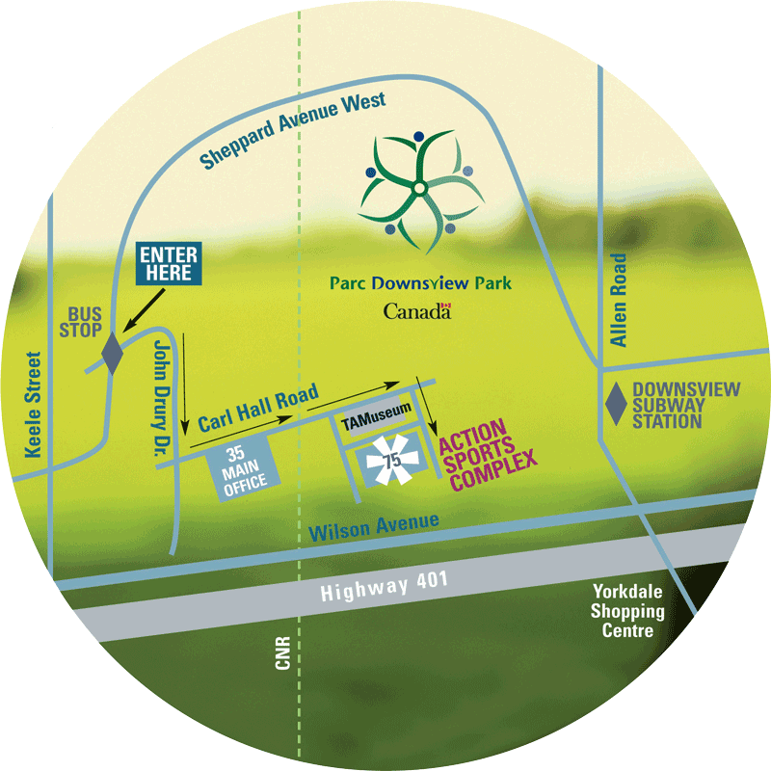
Map to Hoopdome (Directions Below)

Written directions are as follows:
Take Allen Rd. to Sheppard Ave.
Turn onto Sheppard Ave. heading west.
Follow Sheppard Ave. to John Drury Dr.
Turn left onto John Drury Dr.
Turn left onto Carl Hall Rd.
Follow Carl Hall Rd. until Action Sports Complex (Hangar Facility), which will be on your right
Hoopdome is inside Action Sports Complex – Address: 75 Carl Hall Rd.

